Prompt #2 Verify Database Loads

Prompt #3 Insert a document.



I realized after the fact that the numbers were not strings, but integers, so I used the update function to change them.

Verify Document Creation

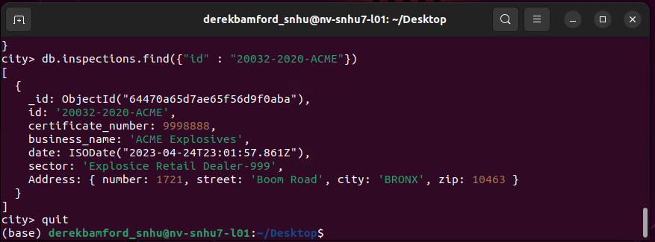

Prompt #4 MongoDB queries

The number of individual sectors was found to be 87.

The date used for AUSTIN 2012 is a string while the date used for ACME uses the UTC time element.

13823 businesses had a violation issued.

Prompt #5 Update Document

Updated the fields of business_name and result while also adding a new field called comments.

Prompt #6 Update Many and Delete One

Dot notation was used to query the embedded field

Photo taken after I had already modified the database earlier.

Photo shows zero items in the database contain the city of ROSEDALE and a zip code of 11422 in the address subdocument but does show that there are items in the database that contain the city of ROSEDALE and the zip of 76114, indicating that the update properly executed.

Photo shows the initial number of items in the database with “Violations Issued” for a value in the result field. After using deleteOne the count is decreased by 1 from 13823 to 13822